EXP 6 Write a Servlet to demonstrate session tracking
using HttpSession.

AIM:
To demonstrate session tracking using HttpSession in a simple Online Feedback Collection System login page.
ALGORITHM:
1. Input:
• The user will enter their username and password in a login form.
• The servlet will validate the credentials and create an HTTP session for the user if
authentication is successful.

2. Steps for Implementing Session Tracking with HttpSession:
1. Create the Login Form (HTML):
o Create an HTML form with two input fields for username and password.
o Provide a submit button to send the data to the servlet for authentication.
2. Create the Login Servlet:
o Write a Java servlet class to handle login requests.
o The servlet will:
▪ Retrieve the username and password from the form.
▪ Authenticate the user by comparing the credentials to a stored value
(e.g., hardcoded or from a database).
▪ Create a new HTTP session for the user if the credentials are valid.
▪ Set session attributes such as the user&#39;s username to track the session.

3. Validate User Credentials:
o In the servlet, check if the username and password match the expected
values.

13

o If valid, create a session and store the username in the session.
o If invalid, redirect the user back to the login page with an error message.
4. Create and Track User Session:
o Upon successful login, use the HttpSession object to store the session data.
o Use the session.setAttribute(&quot;username&quot;, username) method to save the
username.
o Optionally, set session timeout using
session.setMaxInactiveInterval(time_in_seconds) to manage session
expiration.

5. Redirect to a Protected Page:
o After a successful login, the user will be redirected to a protected page (e.g., a
dashboard or home page).
o The protected page should check if the user is authenticated by checking the
session attribute.
6. Logout and Session Invalidation:
o Provide a logout feature that invalidates the session using session.invalidate()
when the user logs out.
o After logout, redirect the user back to the login page.
7. Session Expiration:
o If the session expires or the user manually logs out, the session will be
invalidated, and the user will be redirected to the login page.

CODE:
import java.io.*;
import javax.servlet.*;
import javax.servlet.http.*;

public class LoginServlet extends HttpServlet
{
public void doGet(HttpServletRequest request,
HttpServletResponse response)
throws IOException
{
response.setContentType("text/html");

PrintWriter out = response.getWriter();

String name = request.getParameter("name");
out.println("<html><body>");
if(name == null)
{
out.println("<h2>Online Feedback Collection System</h2>");
out.println("<form>");
out.println("User Name: ");
out.println("<input type='text' name='name'>");
out.println("<input type='submit' value='Login'>");
out.println("</form>");
}
else
{
HttpSession session = request.getSession();

session.setAttribute("user", name);

out.println("<h3>Welcome " + name + "</h3>");
out.println("Session Created Successfully");
}
out.println("</body></html>");
}
}

OUTPUT:
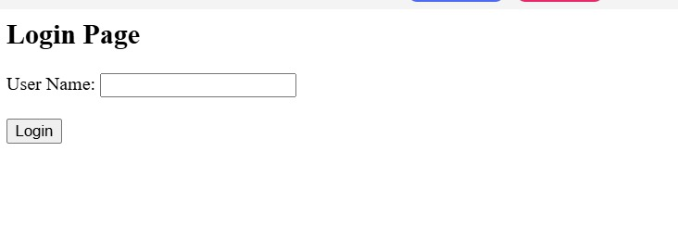

RESULT:
The program executes successfully and creates a session for the logged-in user using HttpSession.

